KT project
Computer network design and modeling

Methodical instructions

- Explain of task description

You need to design and model the network of 5 schools in the Cisco Packet Tracer environments.
The student's technical assignment is given by the teacher in accordance with the MS Excel file, where the task description consists of one line containing 5 network configuration and IP address segments in the school. The line number XX corresponds to the slideXX.jpg in the picture showing the location of the schools on the map and the optical cable connecting them. The following drawings are used in the figure:
- this mark is marked by the district center, but this mark marks  – school. We will mark it not by the number but by the short name of the village marked by the map (for example: Matuizos – is marked by Mat) 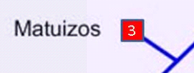

The school node network is located in the center of the district. It has a district router that connects the networks of the schools listed in the task. A server is connected to it.
School Network Configuration.
- In the configuration task, the „+“ character separates physically the number of computers in different classes. The number indicates how many computers are in the classroom. Each class's computers are connected to a separate switch/commutator. If the number of computers in the classroom exceeds the amount of free connections in the switch, additional switches are added to the classroom.
- The „v“ letter indicates the subnets for public use, and the letter "a" indicates the subnetting for the administration. If the letter "a" or "v" is written with "W", the wireless access device needs to be connected to the same subnet. The wireless connection must be secure.
- Each school switches in with each other in a consistent manner.
- If the school has both a public and an administrative subnet, they are connected through a router that connects to the school with the trunk network connecting to the district center. In the case of one subnet (only „v“), the school switcher is connected directly to the trunk network if the router is not set up in the school.
- School computers connect to the switch by copper cable, 100 Mbps Ethernet UTP (Unshielded twisted pair) connections (Fast Ethernet). The switches are connected to the router by copper cable through a 1 Gbps UTP connection (Gigabit Ethernet). Devices connected to fiber optic cables are connected using 1 Gbps (Gigabit Ethernet) optical connectors.
- Router Schools are also required in the following additional cases:
- "+ R" is specified in school network configuration: compulsory school network separation through router;
- The school sign in the diagram is placed in the middle of the cable or on the branch. This means that the school next to the same cable will not be connected by separate connection to the district center, but will be connected sequentially through the router of this school:
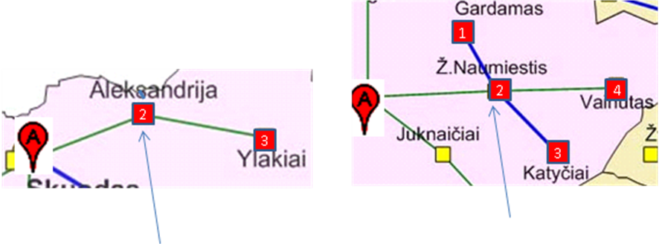
- If the router is needed for two reasons (in the task the school is marked with + R and the school mark is on the cable), it is enough to have one router.
- The center of the district needs a router to connect school networks to the district network and a server that allocates resources to schools. The server needs to activate HTTP and modify index.html. It must contain the name of the student, the task variant schema and configuration data.
- Select the network nodes to reflect the type and location of the node in the topology network. Enter the name of the router by the letter R, the switch K, the computer - the PC, the wireless device W, the laptop connected to it N.
- When connecting computers to the switch, two computers are connected to each subnet marked with the task: the first PCxxx1 to the number 1 marked with the connection, and the last connection to the corresponding number. If the last number is greater than the maximum number of the connection, connect the additional switch and recalculate the connection number accordingly.
- Connect wireless access devices to the corresponding subnet switch and connect them to two laptops. For portable computers, IP numbers are not provided. They must be given temporary access by the wireless access device. Set the SSID (service set identifier) and login passwords.

For assigning network nodes IP there are specified three IP address segments in a task. Addresses from the Public Schools Network segment, the administrative computers and the district server from the "School Administration Networks" segment, for interconnecting routers from the "Server Relations" segment are used for addressing the computers of the public school.

- Network topology

We have such an example of an one variant:
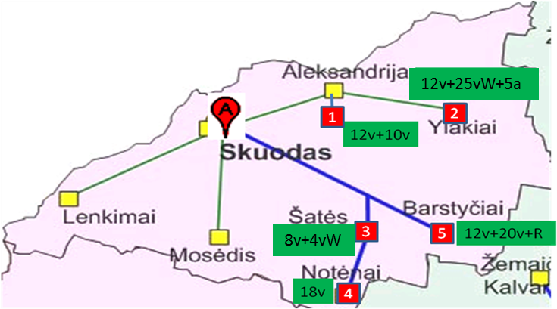
 | School Network Configuration |  |  |  |  | IP number ranges
Jpg No | 1 | 2 | 3 | 4 | 5 | For public networks | For administrative networks | Server Relations
XX | 12v+10v | 12v+25vW+5a | 8v+4vW | 18v | 12v+20v+R | 172.16.0.0/23 | 192.168.0.0/24 | 10.10.10.128/26

In accordance with the above-mentioned rules, Skuodas-Aleksandrija-Ylakiai Alexandria and Ylaki are connected to the district center in separate branches; branch Skuodas-Barstyčiai-Šatė-Notėnai - mixed: Šatės and Barstyčiai are directly connected to Skuodas, but Notėnai are connected from the school of Šačiai in a consistent manner. Routers will be needed:
- In Ylakiai: separate a and v subnets (12v+20v ir 5a)
- In Barstyčiai: since it is +R
- In Šatės: whereas the Notėnai are connected consecutively from Šatės.
Schools (Notchena and Alexandria), which have only „v“ type subnet, we expect a pre-set number of switches: Notėnai -1, Alexandrija-2. Note: If there are not enough connections to connect all computers, we will use additional switches when attaching the equipment. In Alexandrija we connect the switch to each other and connect one of them to the area router. In the school (Ylakiai), which contains the "v" and "a" subunits, we connect Rylak router, where we combine the "v" and "a" subnets. Since the + R configuration is specified in the Barstyčiai configuration, we connect the Barstyčiai schools network with two switches through the Rbar router, and in the Šatės it is necessary to add an intermediate router Rsat because of the need to connect the Notėnai school. In the public subnets of Šačiai and Ylakiai, you will still need to connect the wireless access devices W1-sat-v2 and W1-ylak-v2 to the switch. We get the topology diagram shown below.

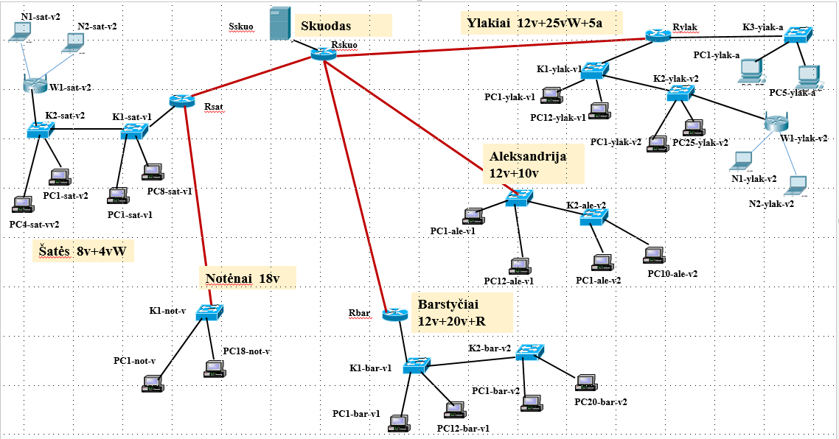

- Distribution of IP addresses
In the network topology, we divide individual IP subnets and determine the number of addressable interfaces in them. We first determine how many IP addresses are required for each subnet. We count the computers in the subnet and add one address to the router's connection and the wireless access device if it is provided in that subnet.
In our example:
LAN | Number of interfaces | Subnet type | Subnet size | Prefix | Mask | Address range from - to
Sskuo-Rskuo | 1+1 | Admin
Rskuo-Rylak | 1+1 | Server Relations
Rskuo-Rsat | 1+1 | Server Relations
Rskuo-Rbar | 1+1 | Server Relations
sat | 8+4+1+1 | Public
not | 18+1 | Public
bar | 12+20+1 | Public
ale | 12+10+1 | Public
ylak-v | 12+25+1+1 | Public
Ylak-a | 5+1 | Admin
Note: The address of the beginning of the segment should always be divisible by the
segment size.
We set the required address segments sizes. Remember that segment sizes can be only 2^{n}, in addition, firts and last numbers are not used for numbering (subnet address and Broadcast address). For example, seven interfaces already require 16 address segments.
We select subnetworks from the given address segments by subnet type. The prefix and mask are counted or taken from this table:
Prefix | Mask | Address Segment Size
/30 | 255.255.255.252 | 4
/29 | 255.255.255.248 | 8
/28 | 255.255.255.240 | 16
/27 | 255.255.255.224 | 32
/26 | 255.255.255.192 | 64
/25 | 255.255.255.128 | 128
/24 | 255.255.255.0 | 256
/23 | 255.255.254.0 | 512
/22 | 255.255.252.0 | 1024

In the table we will set the required subnet sizes and their prefixes and masks.
LAN | Number of interfaces | Subnet type | Subnet size | Prefix | Mask | Address range from - to
Sskuo-Rskuo | 2 | Admin | 4 | /30 | 255.255.255.252
Rskuo-Rylak | 2 | Server Relations | 4 | /30 | 255.255.255.252
Rskuo-Rsat | 2 | Server Relations | 4 | /30 | 255.255.255.252
Rskuo-Rbar | 2 | Server Relations | 4 | /30 | 255.255.255.252
sat | 14 | Public | 16 | /28 | 255.255.255.240
not | 19 | Public | 32 | /27 | 255.255.255.224
bar | 33 | Public | 64 | /26 | 255.255.255.192
ale | 23 | Public | 32 | /27 | 255.255.255.224
ylak-v | 39 | Public | 64 | /26 | 255.255.255.192
Ylak-a | 6 | Admin | 8 | /29 | 255.255.255.248

So if Sskuo-Rskuo assigns 4 addresses to the subnet of 192.168.0.0/30, then we can not allocate 8 addresses from 192.168.0.4/29 to the next 8 address subfolders of Ylak-a, and we need to allocate from 192.168.0.8/29. The same situation goes from sat-not-bar and from ale to ylak-v lines. Problems can be avoided by first assigning addresses to larger subnets, for example. placing the subnetting table in descending order:
LAN | Number of interfaces | Subnet type | Subnet size | Prefix | Mask | Address range from - to
Rskuo-Rylak | 2 | Server Relations | 4 | /30 | 255.255.255.252
Rskuo-Rsat | 2 | Server Relations | 4 | /30 | 255.255.255.252
Rskuo-Rbar | 2 | Server Relations | 4 | /30 | 255.255.255.252
bar | 33 | Public | 64 | /26 | 255.255.255.192
ylak-v | 39 | Public | 64 | /26 | 255.255.255.192
not | 19 | Public | 32 | /27 | 255.255.255.224
ale | 23 | Public | 32 | /27 | 255.255.255.224
sat | 14 | Public | 16 | /28 | 255.255.255.240
Ylak-a | 6 | Admin | 8 | /29 | 255.255.255.248
Sskuo-Rskuo | 2 | Admin | 4 | /30 | 255.255.255.252

In the last column, we write the beginning and end addresses of the address segment. For example if the subnet size is 64 addresses and the subnet is 192.168.91.0/26, then the subnet's address set will be 192.168.91.0-192.168.92.63. Let's not forget that the address of the interfaces never uses the first and last address, i.e. For interfaces there are 62 addresses 192.168.91.1-192.168.92.62.

According to the task we have the following IP address:
Public School Networks | 172.16.0.0/23
For administrative networks | 192.168.0.0/24
Server Relation networks | 10.10.10.128/26

LAN | Number of interfaces | Subnet type | Subnet size | Prefix | Mask | Address range from - to
Rskuo-Rylak | 2 | Server Relations | 4 | /30 | 255.255.255.252 | 10.10.10.128-10.10.10.131
Rskuo-Rsat | 2 | Server Relations | 4 | /30 | 255.255.255.252 | 10.10.10.132-10.10.10.135
Rskuo-Rbar | 2 | Server Relations | 4 | /30 | 255.255.255.252 | 10.10.10.136-10.10.10.139
ylak-v | 39 | Public | 64 | /26 | 255.255.255.192 | 172.16.0.0-172.16.0.63
bar | 33 | Public | 64 | /26 | 255.255.255.192 | 172.16.0.64-172.16.0.127
ale | 23 | Public | 32 | /27 | 255.255.255.224 | 172.16.0.128-172.16.0.159
not | 19 | Public | 32 | /27 | 255.255.255.224 | 172.16.0.160-172.16.0.191
sat | 14 | Public | 16 | /28 | 255.255.255.240 | 172.16.0.192-172.16.0.207
Ylak-a | 6 | Admin | 8 | /29 | 255.255.255.248 | 192.168.0.0-192.168.0.7
Sskuo-Rskuo | 2 | Admin | 4 | /30 | 255.255.255.252 | 192.168.0.8-192.168.0.11

It's useful to know when addressing addresses that the address segments are left unused so that we can expand the network by performing tasks specified in the job defense.
Purpose | Given segment | Used | Left free
Public School Networks | 172.16.0.0/23 | 172.16.0.0-172.16.0.207 | 172.16.0.208-172.16.1.255
For administrative networks | 192.168.0.0/24 | 192.168.0.0-192.168.0.11 | 192.168.0.12-192.168.0.255
Server Relation networks | 10.10.10.128/26 | 10.10.10.128-10.10.10.139 | 10.10.10.140-10.10.10.191

In order not to make mistakes in calculating the Gateway addresses manually and by assigning IP addresses to computers, we create an additional table:
LAN | Number of interfaces | Mask | Address range from - to | Gateway (Router connection) address | Computer Addresses | The address for wireless  device
ylak-v | 37 | 255.255.255.192 | 172.16.0.0-63 | 172.16.0.62 | 172.16.0.1-37 | 172.16.0.38
bar | 32 | 255.255.255.192 | 172.16.0.64-127 | 172.16.0.126 | 172.16.0.65-96
ale | 22 | 255.255.255.224 | 172.16.0.128-159 | 172.16.0.158 | 172.16.0.129-150
not | 18 | 255.255.255.224 | 172.16.0.160-191 | 172.16.0.190 | 172.16.0.161-178
sat | 12 | 255.255.255.240 | 172.16.0.192-207 | 172.16.0.206 | 172.16.0.193-204 | 172.16.0.205
ylak-a | 5 | 255.255.255.248 | 192.168.0.0-7 | 192.168.0.6 | 192.168.0.1-5
Sskuo-Rskuo | 1 | 255.255.255.252 | 192.168.0.8-11 | 192.168.0.10 | 192.168.0.9

If you are working to this place, in case of doubt, you should consult with the teacher. Implement a network under a false project will not succeed.
We will create route tables later, when Cisco Packet Tracer will collect network elements, connect them and configure the IP addresses.

- Network topology in Cisco Packet Tracer

We create the topology in the following order:
- Choosing the right network devices.
  - Routers. Required routers with Gigabit Ethernet for both UTP and optical connectors. The supplied „Router PT“ or „Router PT Empty“.
  - Switches Fast Ethernet UTP connections for computers and Gigabit Ethernet UTP connections for interconnections are required. These requirements are best suited to 2950T or 2960 models with 24 FastEthernet and 2 Gigabit Ethernet connections. However, they do not have optical connections and are not suitable for connecting to the stencil network. The Module „Switch PT Empty“ is suitable for this, in which we can collect the required modular combination up to 10 connections. In our example, we will use these switches to connect Notėnai and Aleksandrija schools networks to the trunk network.
  - Access point type devices are not very suitable for the implementation of a wireless access device. We do not want static IP addresses for laptops, and Dynamic Host Configuration Protocol (DHCP) distributions require appropriate servers in schools. We will use the wireless router WRT300N. After seeing its properties, we see that it is able to provide a static IP address, and for incoming laptops it can be set to a DHCP server and share IP numbers from the address range of the regulated size of 192.168.0.0/24.

- We create the devices provided by the network topology scheme on the desktop. It is convenient to take and complete each one by one network zone, starting from the district center. Under the topological scheme, we designate the names of the devices, and configure the IP addresses of computers and router interfaces according to the IP address table. In some locations there will be a shortage of connecting switches in accordance with the rules in Chapter 1, Section 10. We will need to connect additional commutators that are not signed in the topology diagram.
- Device connection. For connection of devices we can use the "Automaticaly choose" type of connection, but it automatically selects the interface. Better to choose a specific one: fiber – optic, Cooper Straight-Through – connecting computers with switches and switches with routers. Among the same type of devices is the used old method Cooper Cross-Over. We will choose the coonectin links by ourselves.

In our example, we upload Rskuo, we add a module for 1CFE server connection and four modules for 1FGE for connection of sockets. We add and connect the server, replace the names, set the IP addresses to the interfaces, and add the gateway to the server:

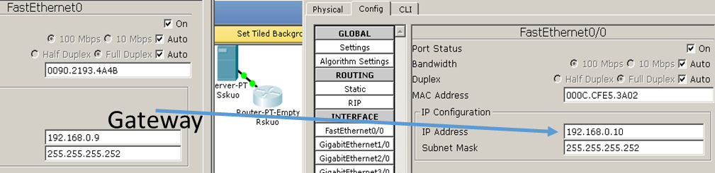

On the server, we activate the HTTP service, we edit index.html by entering your name, surname, gr. and the task (load the task image into ... Cisco Packet Tracer 6.2\saves).

We also collect the network of Šačiai School. On Rsat we will put two 1FGE modules for socket linking and one 1CGE switching connection, connect the two routers and connect two switches. We set the IP addresses for the Rskuo-Rsat connection from the table, without taking the edge, that is, typing 10.10.10.33 and 10.10.10.34. On the CGE connection to the switch, we place the last possible IP number from the segment sat: 172.16.0.206. For all nodes in the sat subnet, this address will be Gateway.

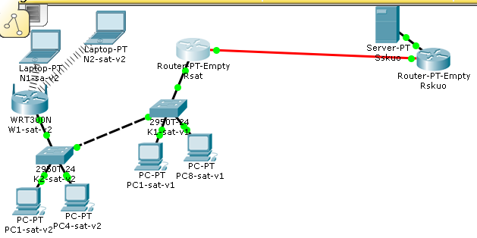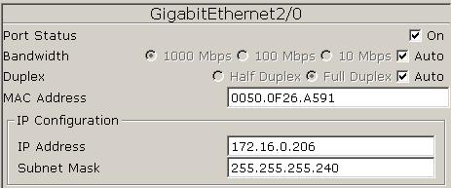

We connect computers to the K1-sat-v1 FastEthernet 0/1 and 0/8 interfaces. We put the switch K2-sat-v2, connect the switches via Gigabit Ethernet interfaces, connect the FastEthernet 0/1 and 0/4 interfaces, and 0/5 to the 0/5 interface to the wireless router (Internet interface). We take two laptops next to it. They have incorrect interfaces inserted, we change it into the WPC300N. The wireless connection will appear automatically. For computers, we set the IP configurations according to the table. We will name 8 consecutive numbers from 172.16.0.193 to 200 for the first subnet and 4 from 172.16.0.201 to 204 for the second. The wireless router's Internet connection is 172.16.0.205. After passing to the W1-sat-v2 GUI, we will verify that the IP number is set to DHCP enabled and laptops will use ip addresses from 192.168.0.100. Suitable SSID is determined by the school name. However, you can not leave open wireless access. In this work, we will determine at least the minimum security: on the Wireless interface, we set up "WPA2-PSK" with a common password „example“. After completing both tasks in the Wireless LANs on PCs „Desktop“ -> „PC Wirelless“, we can try to connect to each of them:

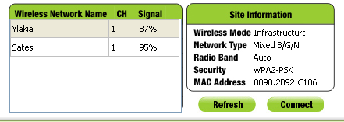

You can try ping from laptops to stationary. However, the connection to the server will not succeed yet: unidentified routes.

Having selected the correct connections for switching to the Notėnai, the remaining switches interfaces are not enough for all 18 computers to connect. Therefore, we will put only two modules in it,

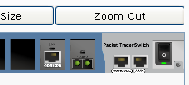

and we connect an additional switch 2950T to the computers. The Notėnai network into the socket is connected by the Šačiai router, so it will be „Gateway“ for Notėnai computers and its corresponding interface will be assigned the address 172.16.0.190.
The Ylakiai router will require one optical and two-copper Gigabit Ethetnet interfaces. When it comes to computers, we notice that the K2-ylak-v2 does not have enought connectors and requires additional connectivity to connect the 25th computer and wireless router.
Rylak connector to the "v" subnetwork we place the address 172.16.0.62 on the subnet 192.168.0.6.

Full simulated network schema:

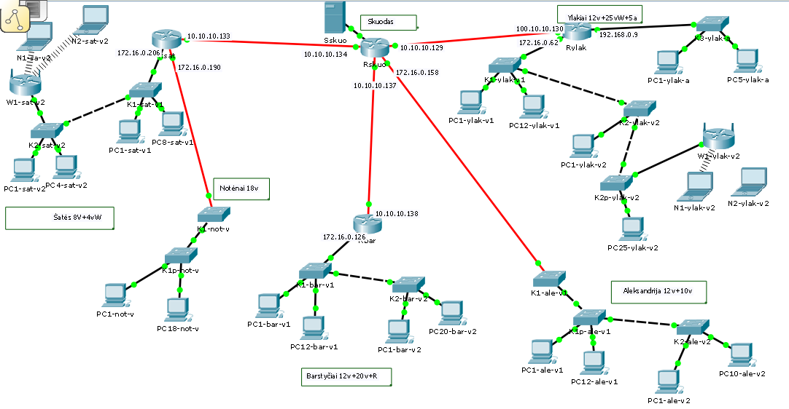
- Creation of route tables

After connecting all the schools and setting the IP numbers, we go to the next stage - the routing between the networks. Routers must ensure the transfer of data between all school networks and the server, as well as between school networks with each other.
- Verifying the addresses of the router connections, aligning with the IP address table, verify that all required connections have specific IP addresses. It's worth knowing and marking the router interface numbers in the desktop schema.
- We create routing tables for routers by indicating paths to those networks that are not directly connected to the router connections (the latter will automatically be included).

We will create a routing table for Router Rskuo over those networks that are accessible through other routers. From Rskuo through Rsat, the routers are accessed by sat and not via Rbar - bar and through Rylak ylak-v and ylak-a. So, we will list them in the table:
Rskuo
Marking | Network IP Address | Network Mask | Through which router | The next hop address
sat | 172.16.0.192 | 255.255.255.240 | Rsat
not | 172.16.0.160 | 255.255.255.224 | Rsat
bar | 172.16.0.64 | 255.255.255.192 | Rbar
Ylak-v | 172.16.0.0 | 255.255.255.192 | Rylak
Ylak-a | 192.168.0.0 | 255.255.255.248 | Rylak
It is necessary to list the IP addresses of neigbour routers. It is necessary here to specify the address of the next router's connection address that connects to Rskuo.
Rskuo
Marking | Network IP Address | Network Mask | Through which router | The next hop address
sat | 172.16.0.192 | 255.255.255.240 | Rsat | 10.10.10.133
not | 172.16.0.160 | 255.255.255.224 | Rsat | 10.10.10.133
bar | 172.16.0.64 | 255.255.255.192 | Rbars | 10.10.10.138
Ylak-v | 172.16.0.0 | 255.255.255.192 | Rylak | 10.10.10.130
Ylak-a | 192.168.0.0 | 255.255.255.248 | Rylak | 10.10.10.130

Similarly, we create routing tables for routers Rbars, Rsat and Rylak

Rbar:
Marking | Network IP Address | Network Mask | Through which router | The next hop address
Sskuo-Rskuo | 192.168.0.8 | 255.255.255.252 | Rskuo | 10.10.10.137
sat | 172.16.0.192 | 255.255.255.240 | Rskuo | 10.10.10.137
not | 172.16.0.160 | 255.255.255.224 | Rskuo | 10.10.10.137
Ylak-v | 172.16.0.0 | 255.255.255.192 | Rskuo | 10.10.10.137
Ylak-a | 192.168.0.0 | 255.255.255.248 | Rskuo | 10.10.10.137
ale | 172.16.0.128 | 255.255.255.224 | Rskuo | 10.10.10.137
In the schema, we see that the path for all the above networks is the same: via Rskuo the Gig4/0 connection.

Rsat:
Marking | Network IP Address | Network Mask | Through which router | The next hop address
Sskuo-Rskuo | 192.168.0.8 | 255.255.255.252 | Rskuo | 10.10.10.134
bar | 172.16.0.64 | 255.255.255.192 | Rskuo | 10.10.10.134
Ylak-v | 172.16.0.0 | 255.255.255.192 | Rskuo | 10.10.10.134
Ylak-a | 192.168.0.0 | 255.255.255.248 | Rskuo | 10.10.10.134
ale | 172.16.0.128 | 255.255.255.224 | Rskuo | 10.10.10.134
The path to the listed networks goes through the Rskuo Gig1/0 connector, connecting the sat network and the not network directly.

Rylak:
Marking | Network IP Address | Network Mask | Through which router | The next hop address
Sskuo-Rskuo | 192.168.0.8 | 255.255.255.252 | Rskuo | 10.10.10.129
bar | 172.16.0.64 | 255.255.255.192 | Rskuo | 10.10.10.129
sat | 172.16.0.192 | 255.255.255.240 | Rskuo | 10.10.10.129
not | 172.16.0.160 | 255.255.255.224 | Rskuo | 10.10.10.129
ale | 172.16.0.128 | 255.255.255.224 | Rskuo | 10.10.10.129

Configuring “Routing-> Static“ Tables for Routers:

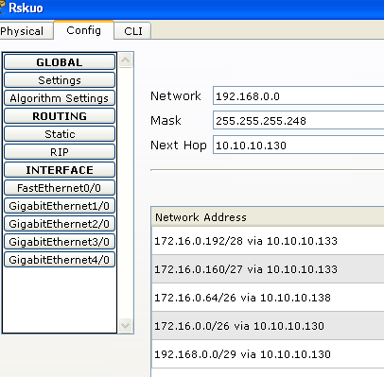

- Network Configuration Testing

- We test the operation of the network from computers to the server and other computers by allowing ping and tracert commands through the browser to connect to the server:
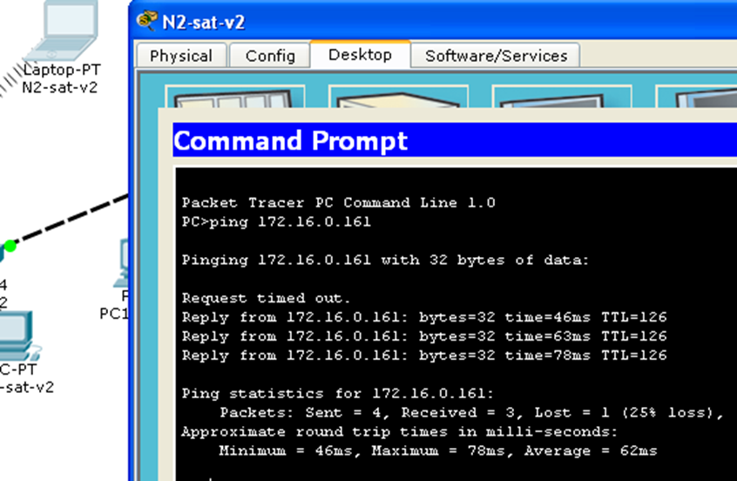
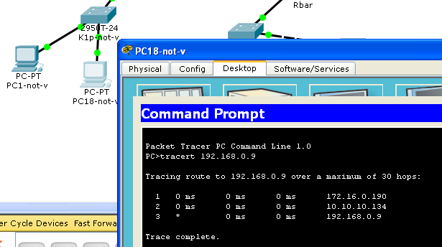

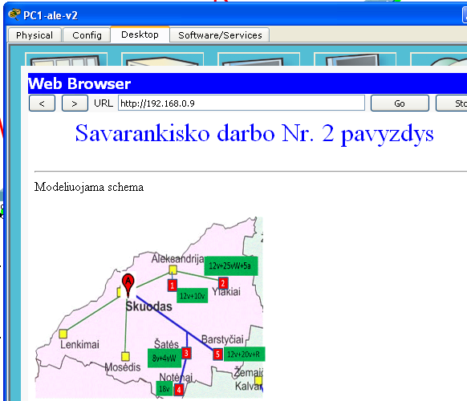

You can try adding an "Add simple PDU" envelope to the start and end nodes, switching from Realtime to Simulation mode and clicking Play to track the packet movement on the network.

- Conclusions of the work
Describe how much the results are for the task, whether the task is complete, whether there are problems and what problems
- Work report

stage No. | Series  No. | Part name
1 stage | 1 | Introduction | To formulate the aim of the work - to design a computer network of schools in the specified district. Provide variant number, task image, describe other parameters specified in the task
1 stage | 2 | Network topology design | Describe the method of school network interconnection, the layout and purpose of the routers, and provide a topological schema with node names.
1 stage | 3 | IP distribution | Provide IP distribution tables
2 stage | 4 | Network simulation | Provide a network view with the necessary marks
2 stage | 5 | Creation of routing tables | Provide routing tables for all routers
2 stage | 6 | Network Configuration Testing | Provide network test result tables (screenshots)
2 stage | 7 | Conclusions | Describe how much the results are for the task, whether the task is complete, whether there are problems and what problems

- Protection

Provide the report of the KT project and the operating model of the network;
Prove that the model works correctly. Minimum requirements for a positive evaluation of the model: the server must be accessed by ping from at least one subnet;
To be able to explain network topology and configuration;
Perform the teacher's specified changes to the topology, configuration, or testing parameters.

